2015 June MCD Ball Dance Descriptions

PRIDE OF ERIN
Written by C Wood of Leith, Scotland to celebrate the Irish in Scotland in 1911 Partners in Open Ballroom hold facing line of dance (LOD) / 32 bars
4 Starting on outside feet, take 2 slow steps forward, then 3 steps forward raising inside feet to about ankle height, toe pointed. (SSQQS)
4 Starting with inside foot take 2 slow steps backward. Then 3 steps backward (SSQQS) turning to face partner and join hands.
2 Man swivels right foot, lady swivels left then step other foot against LOD. Then men swivels left steps forward right, lady swivels right steps forward left then repeat.
2 Repeat swivels and steps.
4 Turn to face LOD and waltz solo along LOD 2 turns (12 steps), finish facing partner.
4 Holding hands balance forward (on left) and back then waltz to opposite places, lady passing under man’s right arm.
4 Repeat back to place.
8 Waltz

ARKANSAS TRAVELLER
Square Set / 32 bar American reel (eg. Arkansas Traveller, Over the Waterfall, Westfork Girl, June Apple)
8 Top couples forward and back, twice -- (holding nearest hand, 4 steps each way)
2 Top couples right-arm full turn with opposite
2 + left-arm full turn with partner
2 + right-arm full turn with corner -- (all couples now involved)
2 + left-arm full turn with partner
8 All swing your corner -- (ballroom hold)
8 Promenade -- (with corner, anticlockwise, skaters hold, once around the set until gentlemen return to original places. Everyone has a new partner)
Repeat once with top couples leading
Repeat twice with side couples leading

(Choice when the active couples are advancing and retiring the other couples can syncopate advancing & retiring as well)

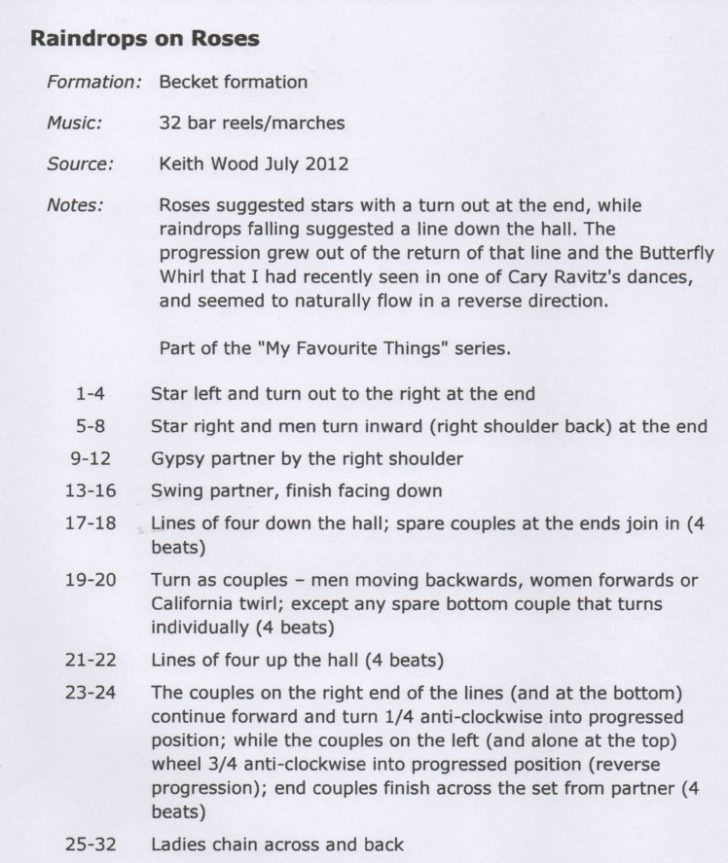

FIRST SET Early version Square set Australian numbering
Each figure is repeated with each couple/or lady leading
Fig 1
½ Rights and Lefts across & back
Set and turn partners
Ladies chain over & back
Promenade ½ way: ½ rights and left
Set & turn partners
Fig 2
Double l’ete
Set and turn partners
Fig 3
1st Lady & opposite walk to opposite position passing by right
Then turn by left hand to take right hands with partners
Balance in line
Promenade to opposite places
1st lady & opposite man advance & retire, then advance & bow and retire
With partners advance and retire: ½ rights and left’s
Fig 4
1st couple advance & retire: advance again 1st lady crosses to side of opposite man
3 in 1 line advance & retire: advance again with active ladies crossing to other man
3 in 1 line advance and retire: advance and circle up: circle left to opposit place
½ rights’ & lefts’ : set and turn partner
Fig 5
Couples 1 & 2 galop double L’ete
Ladies chain over and back
All swing partners or set & turn
Fig 6
Circle up advance & retire twice
Swing corners
Promenade to man’s place & swing

MELBOURNE WALTZ 32 Bar Waltz
Longway
3 Cpl in 4 Cpl set
4 Bars 1st & 2nd Ladies set to partners
Change places ladies between men
4 Bars Repeat
8 Bars 1st Cpl chasse down set & back, cast to 2nd place
(2’s move up) & dance to face 1st corners
8 Bars 1st Cpl turn 1st corners by right hand, touch partner left hands
Turn 2nd corner right hand and touch partner left hand
To dance to 2nd place own side
8 Bars All dance Right Allemande (Regency)
All dance Left Allemande
Except 2nd time thru 1st cast to bottom of set
instead of Left Allemande

(Power’s 1820)
This dance is really a triple minor dance.

MAIRI'S WEDDING
Longways set of 4 couples, 3 active couples / 8 x 40-bar reels
4 1s: RH turn & cast to 2nd place (2s step up)
4 1s: LH turn 11/3 to face first Corners (1L+2G / 1G+3L)
4 1s: 1/2 Reel of 4 with 1st Corners + 1 pass left shoulders
(you can choose to pass right shoulders with your partner)
4 1s: 1/2 Reel of 4 with 2nd Corners (1L+3G / 1G+2L)
4 1s: 1/2 Reel of 4 with 1st Corners
4 1s: 1/2 Reel of 4 with 2nd Corners
8 Left shoulder reels of 3 across (1L up / 1G down - through end Couple)
8 Circle left + Circle right (2s+1s+3s)
40 Repeat from 2nd place with original 1s+3s+4s, 1s drop to the bottom of the set after 2nd time through (becoming 4s)
6x40 Repeat with original 2s / 3s / 4s leading twice each

LOVE ‘EM AND LEAVE ‘EM 64X4 jig Scottish style

Square set tops & sides
1-4 Partners take hands lower promenade hold. Head couples advance and retire while sides promenade around the outside of the set to the opposite places anti clockwise.
5-8 Head couples promenade around the outside of the set to opposite places while sides advance and retire.
1-8 Repeat all and back to place.
1-4 Head couples walk in 4 steps take opposite person in a ballroom hold and galop out between side couples and polka anti-clockwise to gent’s position.
1-8 Sides the same galop between head couples.
1-2 Taking near hands head couples advance 4 steps.
3-5 Take hands with opposite couple and circle left, walking three places. This brings couples inside their own places, with ladies on the left of their partner.
6-8 Let go of opposite’s hand and swing partner back to man’s place.
1-8 Sides repeat
1-2 Gents cast out one place to right to next lady while ladies make quarter turn to face anti-clockwise.
3-8 Ladies take new partner’s left hand in their right hand. Couples promenade to gent’s original place and lady crosses to gent’s right side.
repeat three times to finish with original partner.

WELL HALL
Longways set – Duple proper / Own tune in triple time
(Playford, 11th Ed'n, 1701)
4 1s: Turn RH 11/2
2 1s: Cast / 2s: Lead up
2 1s: Cross right shoulders advance and retire to places (nose to nose)
4 2s: Turn RH 11/2
2 2s: Cast / 2s: Lead up
2 2s: Cross right shoulders advance and retire to places (nose to nose)
2 1G+2L: Change places (1st Cnrs) right shoulder nose to nose
2 1L+2G: Change places (2nd Cnrs) right shoulder nose to nose
2 All: Circle four 1/2 way
2 All: Turn single left shoulder
2 1L+2G: Change places (2nd Cnrs) right shoulder nose to nose
2 1G+2L: Change places (1st Cnrs) right shoulder nose to nose
2 All: Circle four 1/2 way
2 1s: Cast / 2s: Lead up
MARGARET'S WALTZ
Pat Shaw, 1959
Composed for Margaret Grant on her retirement in 1959 as EFDSS representative in Devon

Music: Waltz. Tunes: Margaret's Waltz and Farewell to Devon also composed by Shaw. 32 bar repeat dance.

Formation: Sicilian circle formation, couple facing couple around the room - take inside hands with partner
4B Waltz two steps forward to opposite couple and two back.
4B Right hand turn (shake-hand hold) with opposite person
4B Left hand turn with partner
4B Ladies’ chain half way (using 'Colonial' hold when turning as a couple)
4B With opposite (keeping the same hold): two chassé steps diagonally forward to right and then two diagonally forward to left (couples finishing back to back)
4B All turn right into a right hands across (R H star) with the couple behind, back to original places
4B All right back to back ('do-si-do') with opposite
4B Waltz on to meet new couple

QUEEN OF SHEBA

Formation: Longways set of 4 Couples, 1s & 3s improper. Walking dance in Playford style.

Music: Handel's 'Arrival of the Queen of Sheba' 96-bar
8B Up a double & back (RLR together, RLR together, taking hands with partners) 4B, Gypsy partner (Right shoulder) 4B
8B Down a double & back, Gypsy partner (Left shoulder)
4B RH stars (top 2 couples and bottom 2 couples)
4B Middle 4 LH star while Ends Chase to other end:
1st Lady follows 1st Gent to couple 4's places (proper) while 4th Lady follows 4th Gent to 1st couple's place (improper), all walking clockwise
8B Repeat Stars & Chase: Finish with Gents facing out of the set
8B Side a double & back (all individually) with Ladies following Gents, Gypsy neighbour Right shoulder (1’s with 2’s & 3’s with 4’s)
8B All turn and Ladies face out: Side a double & back with Gents following Ladies, Gypsy neighbour (Left shoulder)
2B End couples (1s+4s): 3/4 RH turn, Ladies take hands and form arches with their partners right hand (up and down the set)
4B 2s and 3s walk clockwise under the arches to places
2B Ends: 1/4 RH turn to places
2B Lady 2 with Gent 3, Lady 3 with Gent 2: 3/4 RH turn, Ladies take hands and form arches with partners right hand across set
4B Ends: walk clockwise under arches
2B 2s and 3s: 1/4 RH turn to places
8B 1s and 4s face away from the set, Lady 2 faces out with Gent 3, Lady 3 faces out with Gent 2: "Starburst" - Forward a double & back, Gypsy this partner (R shoulder)
8B Repeat: Forward a double & back, Gypsy (left shoulder)
(Choice with repeat taking hand with corner dance forward a double from the corners and gypsy with that person)
6B 5 changes Reel of Four on both lines starting: ends facing in, middles standing back to back – walk 1/2 the hey 4B, then one more position 2B: original ends finish in the middle position that was initially furthest from them and original middles finish at the end that was initially behind them ie 1’s & 3’s change and 2’s & 4’s change.
2B All 2-hand turn partner 1/2 way into the other line and immediately turn to start another partial Reel of Four (as above) middle people in line back to back
8B Repeat: Partial Reel of Four on both lines 6B and 2-hand turn partner 1/2 way 2B to original positions

CHARMAINE 32 bar Slow Foxtrot
by Norm Chapple, Melbourne

Over the shoulder prominade hold

1. Left foot 5 forward steps (S.S.Q,Q.S) then swivel keeping feet apart to face against LOD
2. Right foot 5 forward steps against LOD (S,S,Q,Q,S) then swivel with legs apart to face LOD
3. Left foot 2 slow steps forward then cross left foot over right taking 4 quick steps backwards (L,R,L,R)
4.Left foot 1 slow step forward then cross right foot over left and 4 quick steps backwards (R,L,R,L)
5. Right foot 1 slow step and point left, then left foot 1 slow step and point right.

MEN
6. Right foot 2 quick steps forward and swivel to face diag against LOD facing wall and close right foot to left and rest for a quick beat collect partner ballroom hold to left side ( this is often done open 2 hand hold)
7. Left foot one slow step diag against LOD towards wall, to the right of partner, and swivel to face LOD (partner is now on right side) then 3 slow steps forward swivel towards partner to face against LOD.
8. Left foot one slow step and swivel to face partner, ballroom hold chasse 2 steps against LOD and waltz for 4 bars forward LOD.

WOMEN
6. Right foot turn complete circle to right 2 quick steps travelling down LOD ending up facing partner diag to centre step forward right foot to rightside of partner close left foot to right. (Q,Q,Q,Q) take ballroom hold or 2 hand open hold
7. Right foot backwards one slow step diag against LOD and swivel to face against LOD, one slow step backwards LOD and swivel to face LOD, 2 slow steps forward and swivel towards partner to face against LOD.
8. Right foot one slow step against LOD and swivel to face partner ballroom hold chasse 2 steps against LOD and waltz 4 bars forward LOD.
(LOD means Line Of Dance, S means Slow, Q means Quick)

LA RUSSE QUADRILLE Square set/ English numbering anticlockwise

Ladies pass in front of partner to face man from right hand cpl on corner
Men caste behind partner to meet lady on corner set and ballroom hold spin
Travel back to place on the same path: Set & spin partner
1st cpl spin
1’s & 3’s change places active cpl thru middle on way over and on outside way back to place
Sides change places cpl to right of active pass thru middle on way over and outside back to place
Circle left to place (8 bars)
Promenade the set back to place (8 bars)
Repeat 3 times with each cpl taking it in turns to lead, when 2&4 leading sides start the lead thru

CAROUSEL WALTZ 32 bar waltz
Cpl facing couple

8 bars Do-si-do opposite, Do-si-do partner
8 Bars Circle up Balance twice Circle left
8 Bars Balance twice circle right
8 Bars Facing opposit cpl ladies link left elbow thru man’s right elbow
Men link left elbows and all turn around to place
and then promenade on to meet new cpl

SWEETS OF MAY
Irish Ceili dance revived by Nan Quinn, County Armagh c1930
Music: Own tune, Jigs. Formation: Quadrille - tops and sides
Part A - Rings 16B
4B Circle left (7s and 3s)
4B Circle right
4B Circle right
4B Circle left

Part B - Body 32B
4B Tops cross on R side, Sides cross while Tops dance in place
4B Tops cross back while Sides dance in place, Sides cross while Tops dance in place
4B Tops advance while Sides dance in place, Tops retire while Sides advance
4B Tops advance while Sides retire, Tops retire
4B Clapping sequence 'ring the bells'
4B Sidestep 7 and 3s to corner, Ladies in front of partner
8B Repeat clapping then sidestep back, Ladies behind partners
Part C - Lead Around 16B
16B Cpls holding inside hands lead anticlockwise around circle, turn and lead back
Part D - Body 32B
Part E - See-Saw 16B
8B Couples progress around the circle anticlockwise while turning clockwise two hand hold
8B Reverse to places turning anti-clockwise while travelling clockwise two hand hold
Part F - Body 32B
Part G - Sides under Arms 16B
8B Tops arch to their right over Sides and return under (do not change side with partner)
8B Tops arch to their left over Sides and return under
Part H - Body 32B
Part I - Thread the needle 16B
8B All join hands in circle except top Gent and his corner Lady. Lady leads whole set under arch made by 1st Tops to place
8B Repeat with 1st Gent leading the set under arch made by Side couple on left
Part J - Body 32B
Part K - Rings 16B

SWING WALTZ Music: 32 bar waltz
Formation: Couples, start inside hand hold & start outside foot, both facing anticlockwise LOD
4B Advance 3 steps & raise inside foot. Retire 3 steps (start inside
feet finish with feet together)
2B Waltz solo turn – finish 2-hand hold with Partner
2B Chassé 2 steps sideways along LOD (step close, step close).
2B Chassé 2 steps back against line of dance – finish facing
LOD holding nearer hands
2B Step apart 1 waltz step (keeping hands joined) + Change
places (Lady turns under Gent's right arm) –
finish facing against LOD
2B Repeat step away & change places – finish facing along LOD
2B Step away starting inside feet 3 steps to Finish facing Partner
& take 2-hand hold
2B Step & balance forward + Step & balance against line of dance
2B Starting men’s left ladies right Turn to be back to back 3 steps
& balance forward in LOD, keeping nearer hands joined.
2B Balance against line of dance then forwards turning take
3 steps to face Partner & taking 2-hand hold.
2B Step balance through + Step balance back
2B Lady turn under Gent's left arm progressing along line of dance,
while man dances 3 steps forward
2B Lady turn back (under Gent's left arm) dancing back
against line of dance while man dances 3 steps backwards
4B Waltz on (should be reverse waltz)

MAXINA
Couples both facing (L.O.D.) in high promenade hold position.

Rocking. Both rock forward onto left foot then back on right twice.
Starting on left foot take 3 steps and lift foot forward and 3 steps back.
2 slow steps forward stating with left. Then ½ turn clockwise on the right to face against LOD and run 3 quick steps backwards.
Starting right foot repeat the 2 slow ½ turn 3 quick back to place.
Starting left foot take 4 grape vine steps.
2 slow starting left ½ 3 quick then with right 2 slow ½ turn 3 quick.
Staring left take 2 slow steps forward then turn to face partner. Balance away and together take ballroom hold
Waltz. | 24 bars
CHAIN COUBLE QUADRILLE
Double Sicilian progressive- 2 couples in a line facing two couples in a line -- 48 Bar Reel

4B Inside 4 people right hand star
4B Turn partners by left arm 11/2 times
4B Other 4 right hand star
4B Turn partners by left arm 11/2 times to face each other in original places
4B Set twice and spin to finish facing across set
4B Half ladies chain across set
4B Half ladies chain along line
8B Repeat back to place
8B Advance and retire and pass through maintaining ladies chain promenade hold men passing left shoulders.

PORT JACKSON Australian/English
32 Bars Duple Minor
Longways
4 Bars 1st & 2nd Cpls Right hand turn
4 Bars 1st & 2nd Cpls Right hand star
4 Bars 1st & 2nd Cpls Left hand turn
4 bars 1st & 2nd Cpls left hand star
6 Bars 1st Cpl lead down the middle & back
2 Bars 2’s move up while 1’s cast to 2nd place
4 Bars Right Allemande (Regency or Tulloch)
4 Bars Left Allemande ( maintain eye contact)

From Thompson’s Twenty Four Dances 1796

WALTZ COTILLION Country Victorian Version
Quadrille set – numbering 1st couple back to band, 2nd opposite, 3rd to 1sts right and 4th to 1^{sts} left / 4 x128 bars waltz
16 Couple 1: Waltz inside the set to place
8 Ladies 1&2 balance forward and back and cross by right
8 Ladies 3&4 repeat
8 Gents 1&2 repeat
8 Gents 3&4 repeat
8 Couples 1&2 waltz partners to place
8 Couples 3&4 waltz partners back to place
8 (Sides divide to form top and bottom lines)
Lines advance and retire and pass through
(2 steps to advance 2 steps to retire & 4 to cross over)
8 Lines repeat to place
32 All balance waltz chain to place
16 All waltz partners to place
Repeat with each couple waltzing the set to start 3 x 128 bars
When sides leading ladies 3&4 lead the cross over
And tops dividing to form side lines

